SIMATS ENGINEERING (SAVEETHA SCHOOL OF ENGINEERING)
Department of Computer Science and Engineering
ASSESSMENT TOOL 2 – Industry Problem Solving Task

Course Code: | CSA06 | Course Title: | Design and Analysis of Algorithms
CO Assessed: | CO4: Articulation (BL4, BL5) | Assessment: | Assessment Tool 2 – Industry Problem Solving Task
Weightage: | 20% of CIA | Total Marks: | 100
CO4 Statement: | Solve optimization problems using dynamic programming and greedy strategies.
Student Name: | Rafeez ahamed SI | Reg. No.: | 192524078
Section / Batch: | 2025 | Date: | 22-08-2026
Instructions to Students
- Answer the following question. Total Marks: 100.
- Carefully analyze the given questions.
- Explain in detail with sample code if needed.
- Clearly identify all key issues.
- Provide a thorough analysis with validated results and performance evaluation.

Question Type | Focus Area | Questions
Industry Problem Solving Task | Focus on Solving optimization problems using dynamic programming and greedy strategies | Q1

SECTION A – Industry Problem Solving Task

“Q1 Autonomous Robot Task Allocation

Code of Conduct
I (Name / Reg No) certify that this submission is my original work and that I have adhered to the guidelines specified for this assessment. I understand that any violation of academic integrity rules will result in disciplinary action.
Signature of the Student:

RUBRICS FOR CALCULATION
Industry Problem Solving Task

Criteria | Weightage | Level 4 – Exemplary | Level 3 – Proficient | Level 2 – Developing | Level 1 – Beginning
Understanding of Industry Problem | 20% | Comprehensive understanding of real-world problem and constraints | Good understanding with minor gaps in requirements | Basic understanding; some requirements  unclear | Poor understanding; misinterprets problem context
Application of Engineering Concepts | 25% | Applies advanced and relevant concepts effectively to solve  the problem | Applies appropriate concepts with  minor errors | Limited application of concepts | Incorrect or no application of concepts
Solution Design | 25% | Innovative, practical, and feasible solution aligned with industry  standards | Logical and feasible solution with minor gaps | Basic solution with limited feasibility | Unclear or impractical solution
Use of Tools | 15% | Effective use of modern tools, technologies, and real  data | Appropriate use of tools with correct implementation | Limited or inconsistent use of tools | Minimal or incorrect use of tools
Analysis | 10% | Thorough analysis with validated results  and performance evaluation | Good analysis with reasonable validation | Basic analysis with limited validation | Poor or no analysis
Professionalism | 5% | Highly professional, well-documented, and clearly presented work | Good documentation and presentation | Basic documentation with some gaps | Poor documentation and presentation

Marks Evaluation:
Criteria | Wt. | Level 4 – Exemplary | Level 3 – Proficient | Level 2 – Developing | Level 1 – Beginning
Understanding of Industry Problem | 20%
Application of Engineering Concepts | 25%
Solution Design | 25%
Use of Tools | 15%
Analysis | 10%
Professionalism | 5%
Total Marks (100):

Faculty In-charge | Course Coordinator | Head of Department
Name: | Name: | Name:
Signature: | Signature: | Signature:
Date: | Date: | Date:

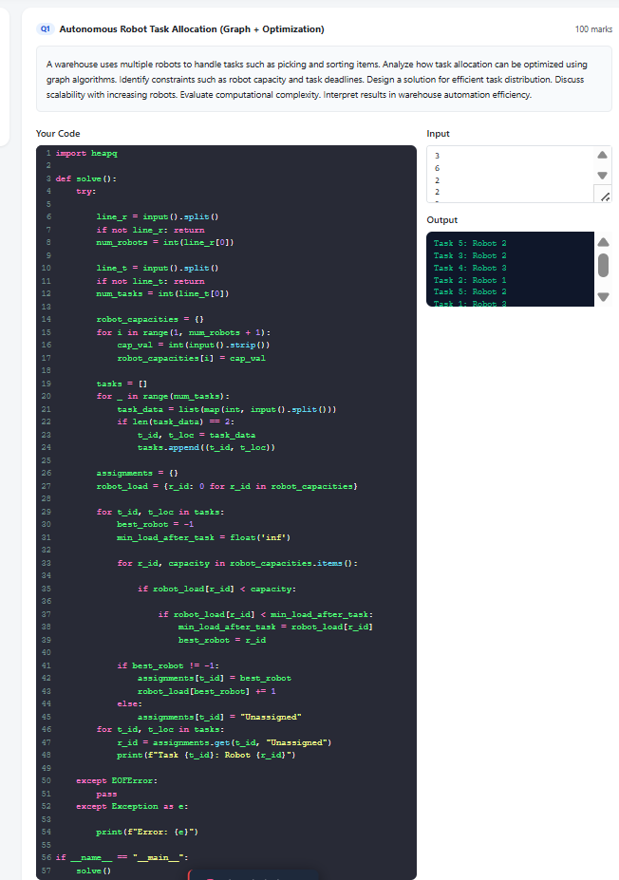

Autonomous Robot Task Allocation (Graph + Optimization)
1) Problem Overview
In a warehouse, multiple autonomous robots must perform incoming tasks such as picking, sorting, and transporting items.
Each task has:
- a location/node in the warehouse
- a deadline (time by which task must be completed)
- a work requirement (e.g., load units, service time)
Each robot has:
- a capacity limit (maximum number of tasks or maximum load/energy)
- a starting point (robot base node)
- a finite time horizon and speed constraints
The goal is to assign tasks to robots such that:
- tasks are completed before deadlines
- robot capacities are not exceeded
- overall efficiency is maximized (e.g., minimize total travel time or maximize number of tasks completed)

2) Graph Modeling Using Graph Algorithms
We model the warehouse as a graph:

(a) Graph Construction
- Create a directed weighted graph G = (V, E)
- V includes:
  - robot start locations (optional nodes)
  - task locations
- E includes paths between locations (aisles/corridors)
- Edge weight w(u, v) represents:
  - travel time from location u to v
  - or distance/cost that can convert into time
(b) Shortest Path Preprocessing (Dijkstra/Floyd-Warshall)
For each robot start and each task node, compute shortest paths:
- Use Dijkstra from each relevant source node
- Obtain minimum travel cost between tasks/robot bases
This makes it easy to estimate time to move between assigned tasks.

3) Optimization Formulation (Task Assignment Under Constraints)
We combine graph distances with optimization.

(a) Decision Variables
Let:
- x_(i, r) = 1 if task i is assigned to robot r, else 0
- optionally, assignment order can be considered, but for a first-stage solution we focus on assignment
(b) Constraints
- Robot capacity constraint
If robot r has capacity C_r:
  - ∑_ix_(i, r) ≤ C_r
- Task deadline constraint
If robot r performs tasks in some planned order, completion time matters:
  - T_(i, r) = estimated completion time of task i if assigned to robot r
  - Must satisfy:
  - T_(i, r) ≤ d_i (deadline)
If exact ordering is hard, practical methods use:
- greedy estimation (e.g., earliest-feasible scheduling)
- dynamic sequencing after assignment
- Each task must be assigned
  - ∑_rx_(i, r) = 1 for all tasks i
(or allow “unassigned” if needed, but penalize it)
(c) Objective Function
Minimize total cost such as:
- total travel time across robots, or
- total tardiness (lateness), or
- maximize tasks completed within deadlines.
Example objective:
min ∑_(i, r)x_(i, r) ⋅ "travel_time"(r → i)+ λ ⋅ "tardiness"
where λ controls importance of meeting deadlines.

4) Solution Design (Practical Algorithm)
A good design is two-stage:

Stage 1: Build a Task-to-Robot Cost/Feasibility Graph
Create a bipartite-like assignment structure:
- Left side: tasks
- Right side: robots
- Weight/cost: estimated time if robot r takes task i, derived from graph shortest paths
Also compute feasibility:
- whether robot r can still complete the task within deadline considering current workload
Stage 2: Optimization via Greedy + Priority (Greedy Scheduling with Constraints)
A common efficient approach:
- Sort tasks by earliest deadlines (Earliest Deadline First idea)
- For each task i, choose the robot r that gives:
  - minimum load increase (or minimum travel time)
  - and does not violate capacity
  - and remains feasible with deadline constraint
- If no robot is feasible, mark task as unassigned or attempt rebalancing.
This is a constraint-aware greedy assignment using graph-derived distances.

Why this works
- Deadlines are handled by task ordering.
- Graph shortest paths provide accurate travel-time cost.
- Capacity prevents overload.
- The greedy decision is fast and scalable.

5) Scalability with Increasing Robots
As number of robots increases:
- The assignment search space grows, but greedy methods avoid exponential complexity.
- Stage 1 preprocessing (shortest paths) can dominate computation.
To scale efficiently:
- Use Dijkstra only from robot start nodes and task nodes (limited sources)
- Cache shortest-path results
- Use heuristics:
  - assign only to top-k feasible robots with smallest cost
- For very large systems:
  - use rolling horizon / receding planning (plan for next time window)
  - use distributed negotiation (robots bid for tasks)

6) Computational Complexity Evaluation
Let:
- |V| = number of locations (nodes)
- |E| = number of edges
- R = number of robots
- T = number of tasks
(a) Shortest Paths (Dijkstra)
If we run Dijkstra from each robot start and each task source (S sources):
- Time: O(S (|E| log |V|))
Often S is much smaller than T or can be cached.

(b) Greedy Assignment
For each task, check feasibility against all robots:
- Time: O(T * R)
Overall complexity:
O(S(|E| log |V|)+ TR)
This is polynomial and efficient for warehouse sizes.

7) Interpreting Results in Warehouse Automation Efficiency
After assignment:
- Higher number of completed tasks before deadlines indicates better efficiency.
- Lower total travel time reduces energy usage and congestion.
- Balanced robot workload prevents some robots from becoming bottlenecks.
- Constraint violations (deadline misses, capacity overflow) show where:
  - the scheduling heuristic needs improvement
  - or additional robots/charging stations are required
- You can measure performance using:
  - number of on-time tasks
  - total tardiness time
  - average robot utilization
  - throughput (tasks/hour)

8) Conclusion
By modeling the warehouse as a weighted graph, computing travel-time via shortest paths, and applying constraint-aware optimization (capacity + deadlines) through greedy assignment, we can design an effective robot task allocation system. The method is scalable, produces fast feasible schedules, and directly improves warehouse automation metrics like throughput, on-time completion, and reduced travel overhead.

